**Interesting Facts of the Life of Dmitri I. Mendeleev**

Basenko Y.V.

Poltava High School No 3

Oh, what a marvellous affirmation of evolutionary theory!

Oh, what a great chain extends from a dog to Mendeleev the chemist!

– Mikhail Bulgakov

Dmitri Ivanovich Mendeleev is a Russian chemist, inventor and world-famous scientist.

He is the creator of the periodic system of chemical elements which may be considered the most widely recognised value of modern science. In order to understand the properties of the known elements and their relationships to one another, Mendeleev developed a card game. He wrote out the properties of each element on them and spent a great deal of time arranging them. Of the elements similar in their properties, he made rows and compared them. He was looking for patterns in the data on the cards. He locked his room and spent hours and days, trying to figure out the puzzle. Mendeleev was the first scientist to arrange all the cards from lowest to highest atomic mass.

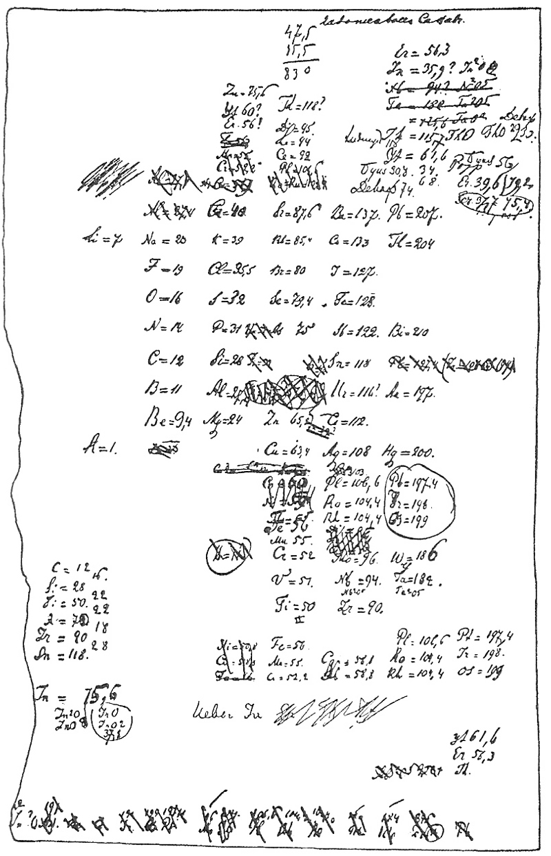

Fig. 1 – Mendeleev’s first sketch of the periodic table of elements

The periodic system presents a very complicated case because it emerged in England, the United States, France, Germany and Russia during the 1860s. The most completed form of the periodic system, developed by Mendeleev, emerged from Russia. Mendeleev published his periodic table of known chemical elements and predicted some more elements to complete the table. The periodic table of chemical elements was proclaimed as the periodic law.

Mendeleev studied the properties of elasticity and expansion of gases, hydrocarbons and explores the origins of oil and wrote some papers to this effect. He developed a theory that petroleum originated from the action of water on metallic carbides inside the earth. He visited the Caucasus, went to America to see the Pennsylvania oil fields. The scientist brought back some technical ideas and presented an [unflattering](http://www.answers.com/topic/unflattering" \t "_top) view of America in his book *The Oil Industry in the North American State of Pennsylvania and the Caucasus.* Mendeleev's papers in terms of learning of oil production were very important for the rapidly developing Russian oil industry.

Mendeleev was an ardent reformer and meteorologist in Russia. It was the interest that led him to a courageous solo ascent in a hydrogen balloon to observe a solar eclipse on August 7th 1887.

Dawn. It was overcast. Between the railway line and the station a balloon, surrounded by fence made of poles, was swaying. There was a gas-producing plant close by where soldiers were working.

A crowd assembled and waited for Professor Mendeleev. At 6:25 it broke into applause, and a tall, slightly slouching man with greying hair lying on his shoulders and a long beard, stepped from the crowd and started for the balloon. It was the professor. Mendeleev was greeted more as an adventurer and hero than as a scientist. The eclipse was coming up. Last goodbyes. Kovanko, a tall and slender balloonist, was already in the balloon. In a brown coat and hunting boots, Mendeleev was making his way through a web of ropes.

The following events unfolded in a twinkling. All of a sudden his companion Kovanko jumped out of the basket and the ball went up slowly. A stool and board, which served as a table, flew overboard, and from the bottom of the basket, Mendeleev started throwing down the wet sand with both hands.

Inasmuch as the balloon lacked the power to lift the scientist and his experienced balloonist, Mendeleev made the balloonist leave the basket. At 53 years of age this novice balloonist insisted on ascending alone and carried out a solo flight, rising to an altitude of 11,000 feet and landing two hours later after covering 150 miles.

The scientist planned to combine observing the eclipse with another goal. He wanted to test the possibility of using balloons for military purposes.

The public adored heroism for the greater good of science. The newspapers wrote colourful stories about his bravery.

When the scientist was appointed Director of the Bureau of Weights and Measures, it was in this role that he was directed to formulate new state standards for the production of vodka. As a result of his work, in 1894 new standards for vodka were introduced into Russian law and all vodka had to be produced at 40% alcohol by volume.

“I am surprised myself,” – Mendeleev wrote at the end of his life, “that I have done a lot in my life, and I hope that worked out well.”

References

1. Michael D. Gordin. A Well-Ordered Thing: Dmitrii Mendeleev and the Shadow of the Periodic Table, New York: Basic Books, 2004

2. D.I. Mendeleev. Vozdushny polet iz Klina vo vremia zatmeniya. – Sochineniya. L.-M., 1946, vol. 7, page 469-546

3. Dmitri Mendeleev [Electronic source]: <http://www.answers.com/topic/dmitri-mendeleev>

**Заявка на участь у міжнародній науково-практичній конференції «Менделєєвські читання**

ПІП: Басенко Яніна Віталіївна

Учениця 9-А класу Полтавської спеціалізованої школи І-ІІІ ступенів №3 Полтавської міської ради Полтавської області

Адреса, телефон: м. Полтава, вул. Куйбишева 4, тел. 7-26-19

Назва доповіді: Interesting Facts of the Life of Dmitri I. Mendeleev

Секція: Д. І. Менделєєв - наукова та просвітниціка спадщина.

Форма участі у семінарі: публікація матеріалів.

Підпис\_\_\_\_\_\_\_\_\_\_\_\_\_\_\_\_

Дата 20 вересня 2011р.